# Ws-and-REST-API-Spring-Boot

## Web service

A service delivered over the web.

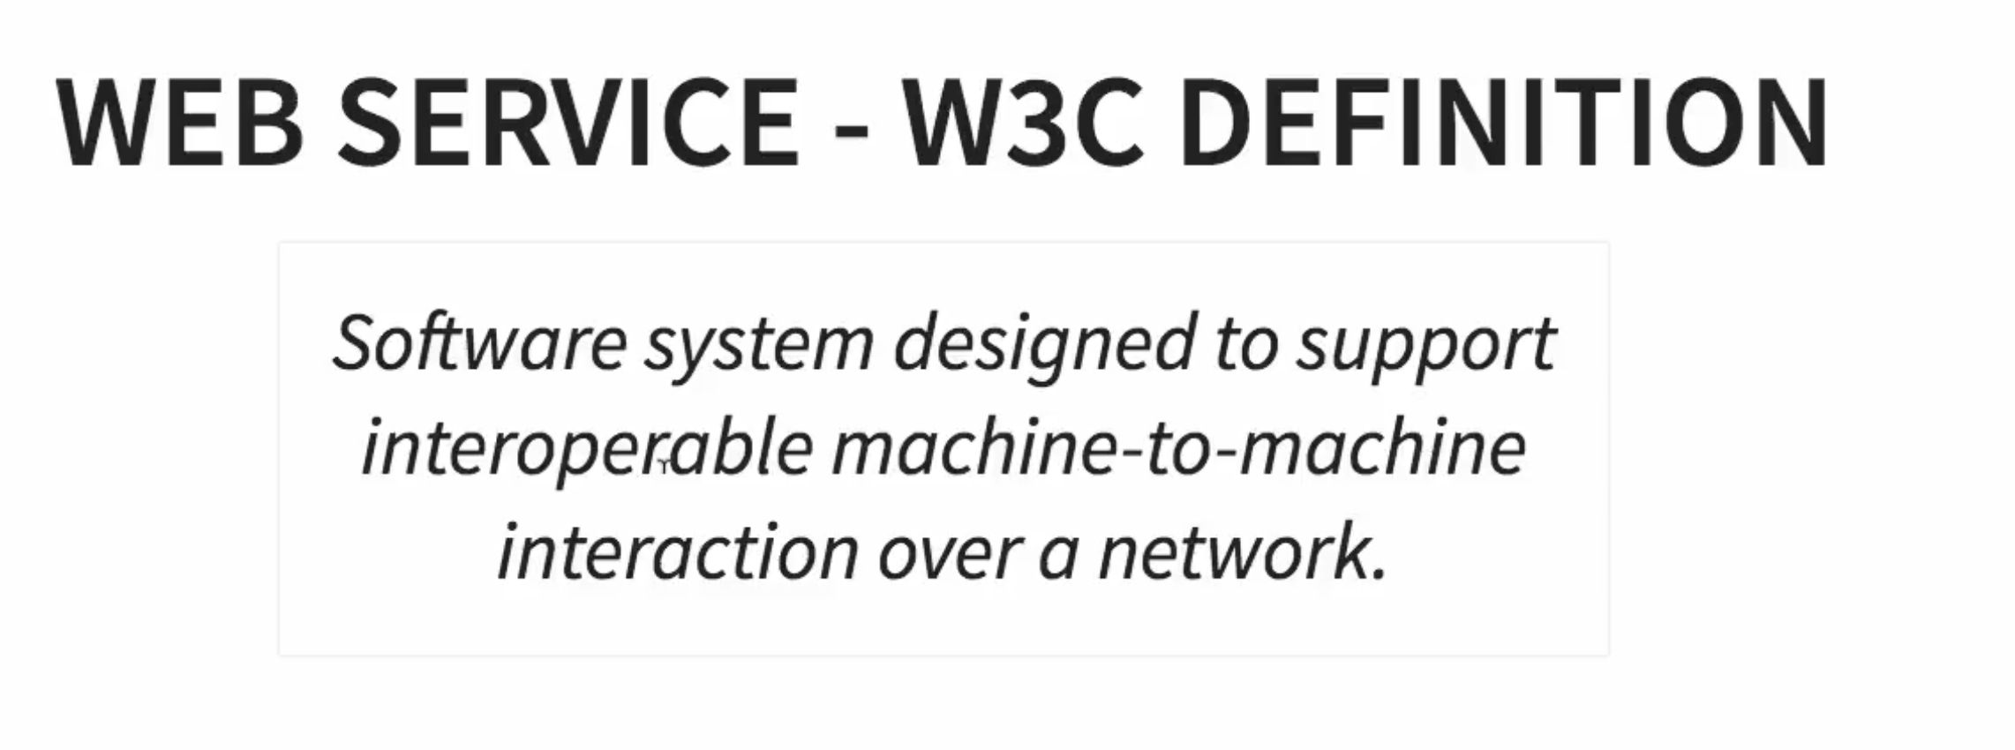

## SOAP services

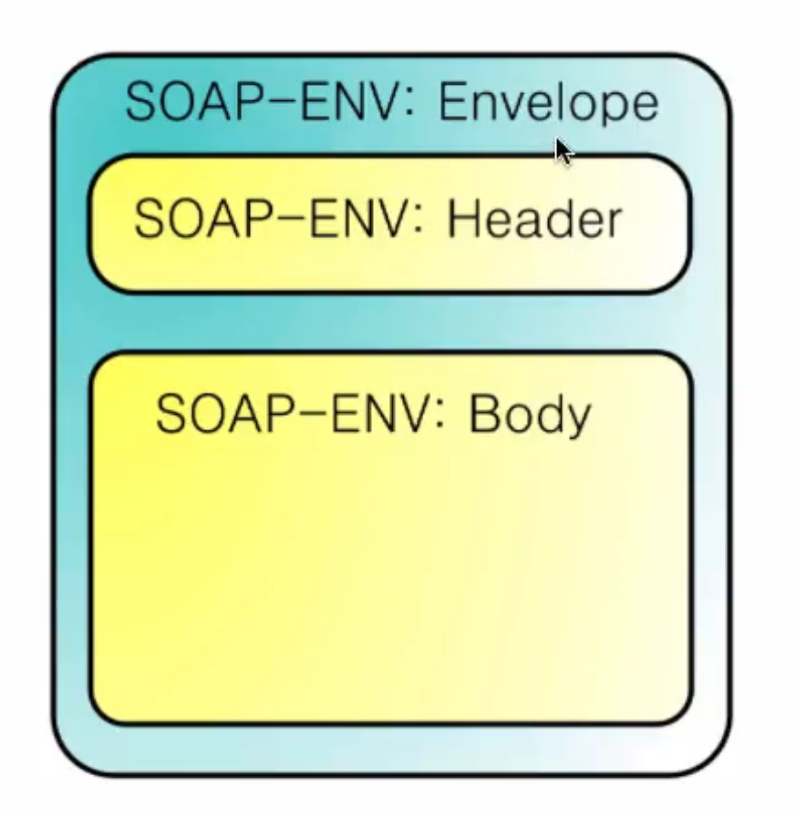

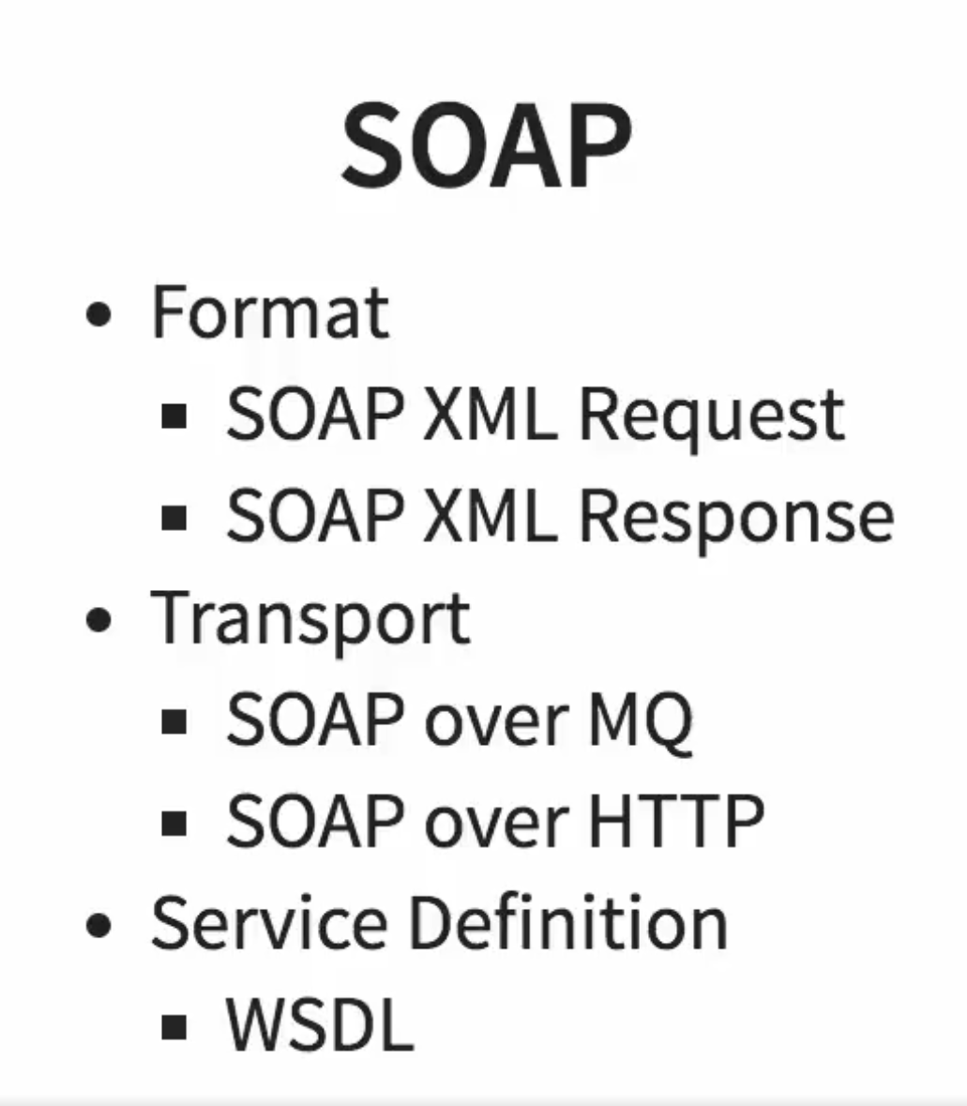

## REST services

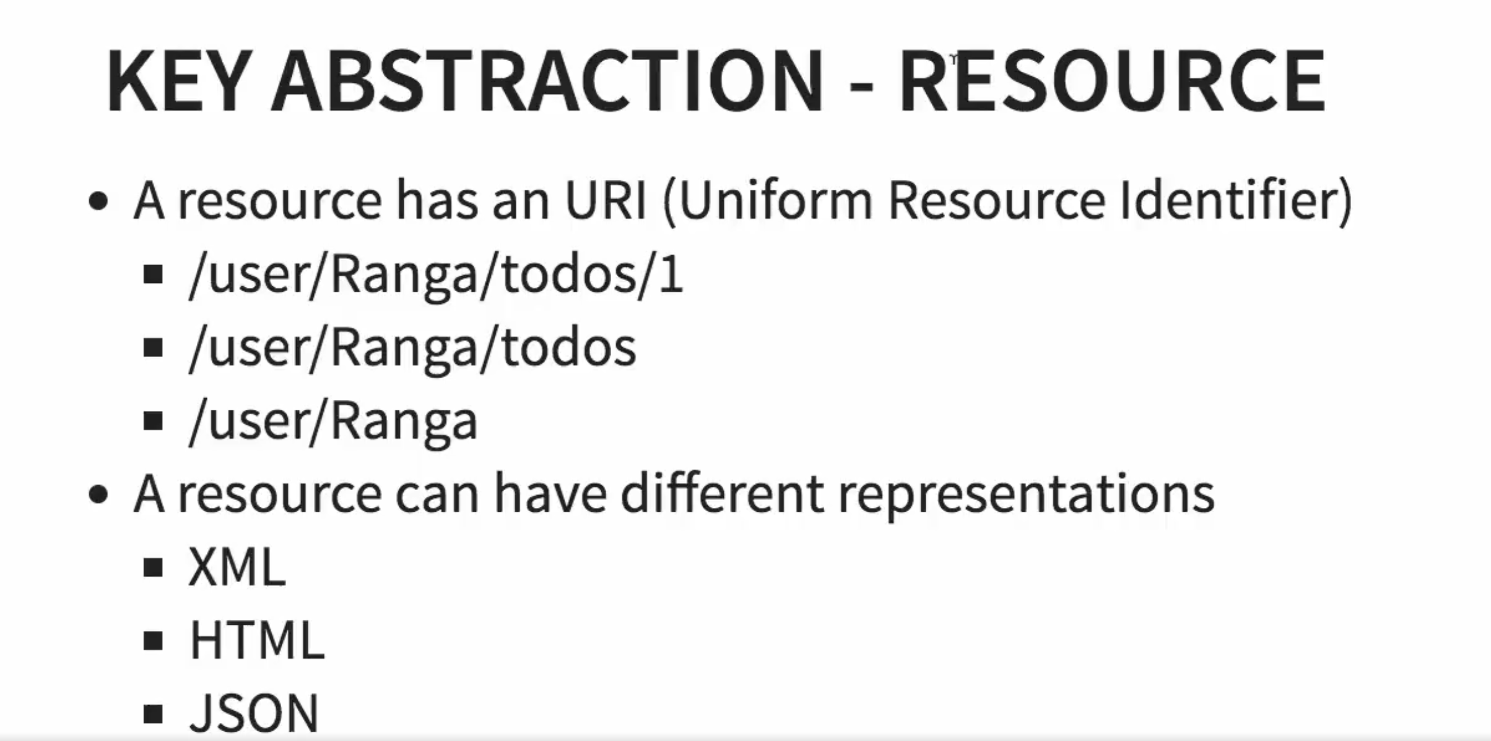

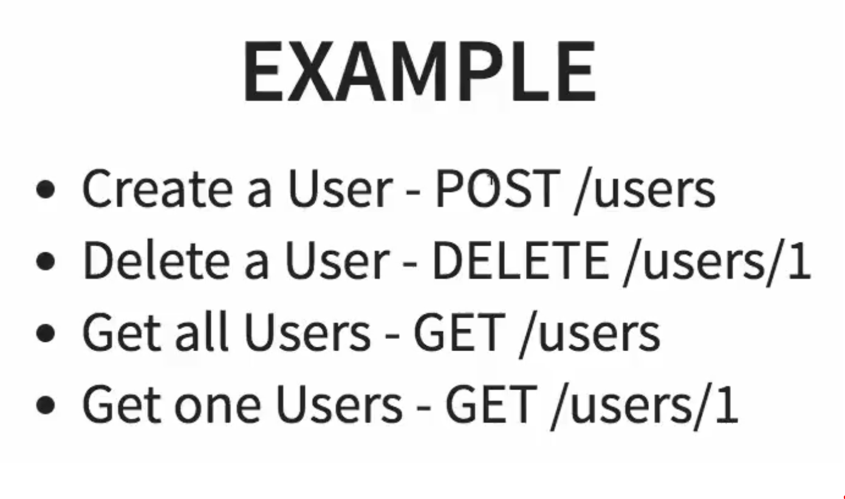

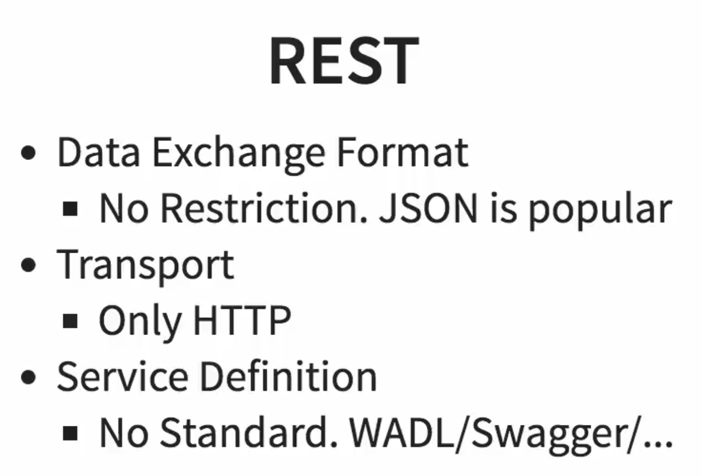

## Multiple package scanning

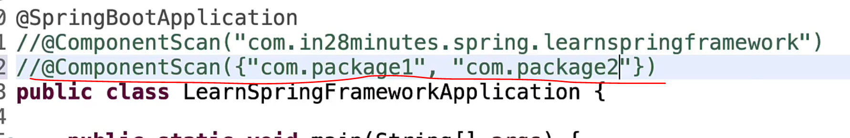

## Dependency injection types

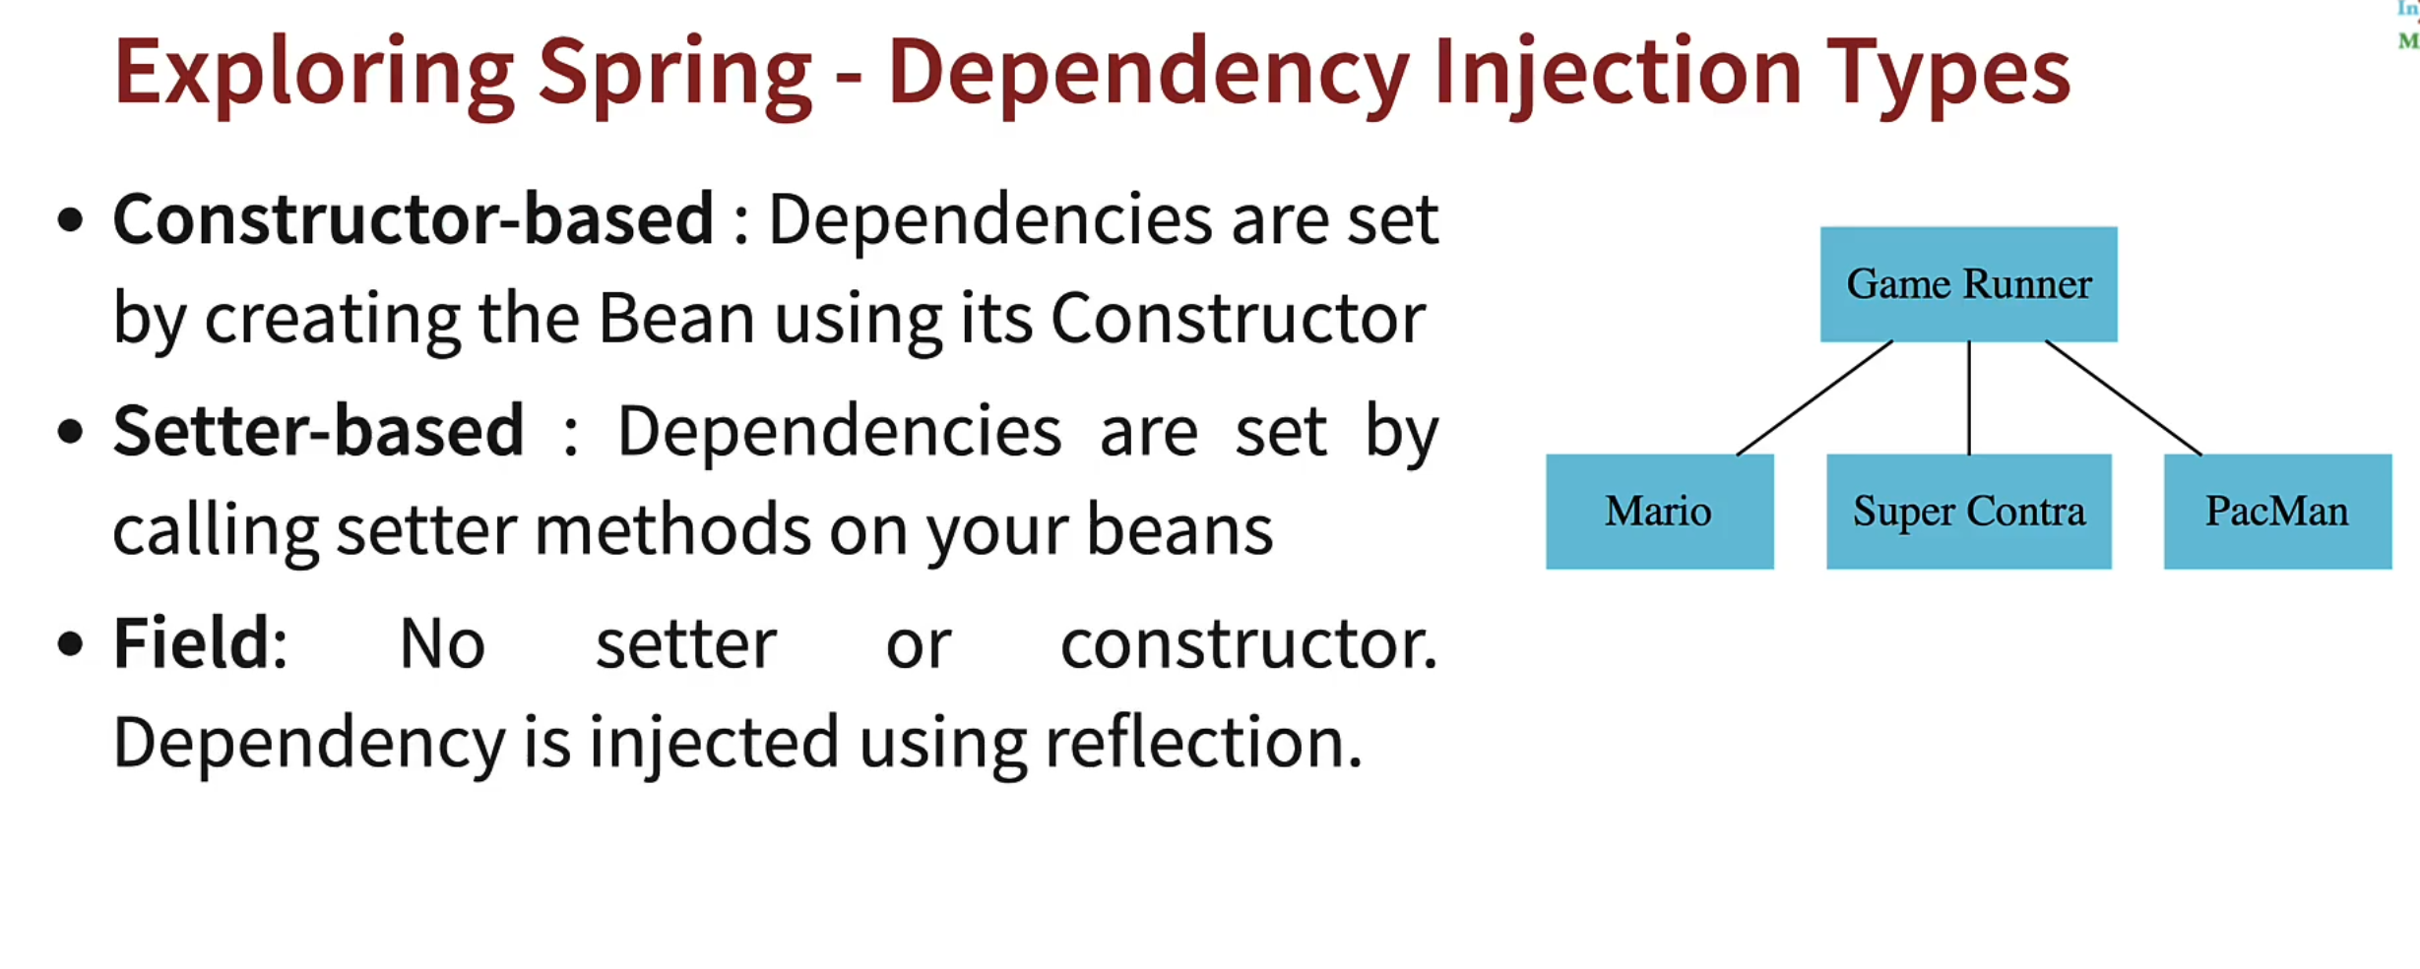

**Constructor injection** in Spring is a method of injecting dependencies into a class through its constructor. This means that the required components are passed into a class at the time of instantiation.

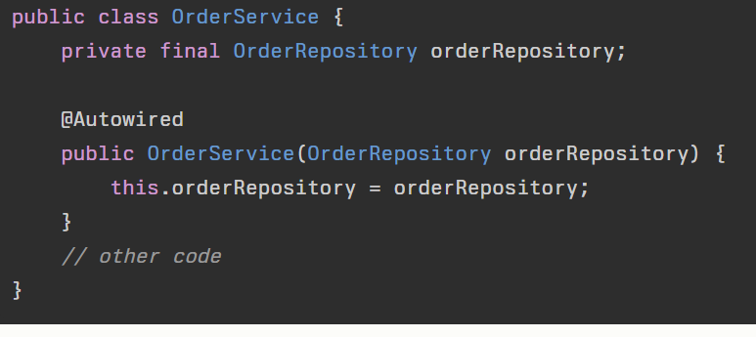

This is also constructor injection

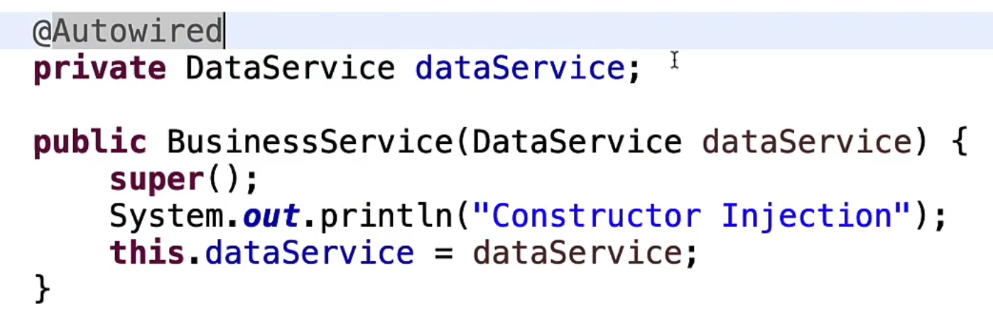

**Setter injection** in Spring is a method of injecting dependencies into a class using setter methods. This means that the required components are provided through setter methods.

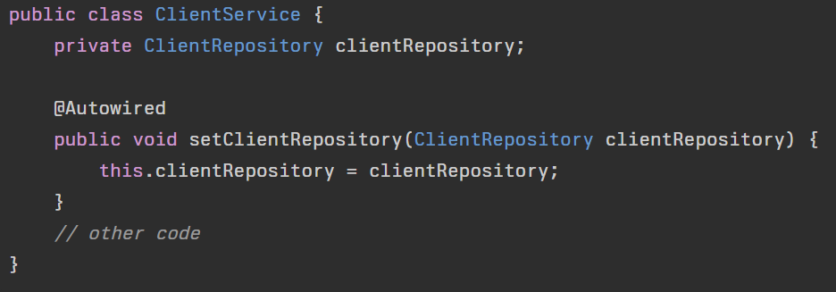

**Field injection** in Spring is a method of injecting dependencies into a class directly through its fields using the @Autowired annotation. This approach allows the dependencies to be directly assigned to the class's fields.

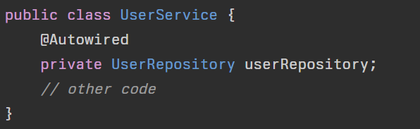

## Spring modules

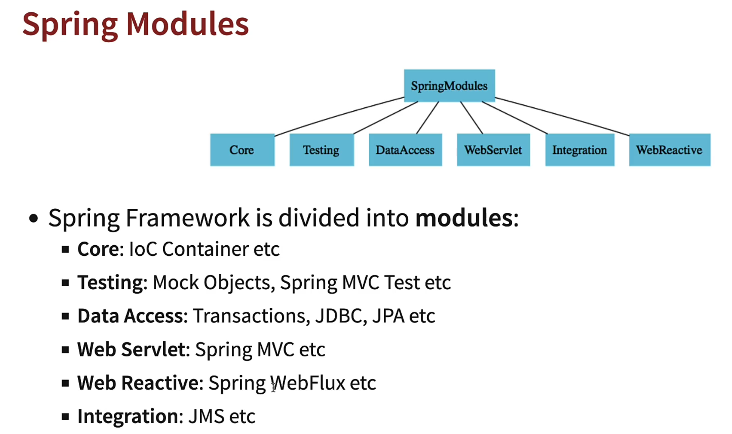

## Spring projects

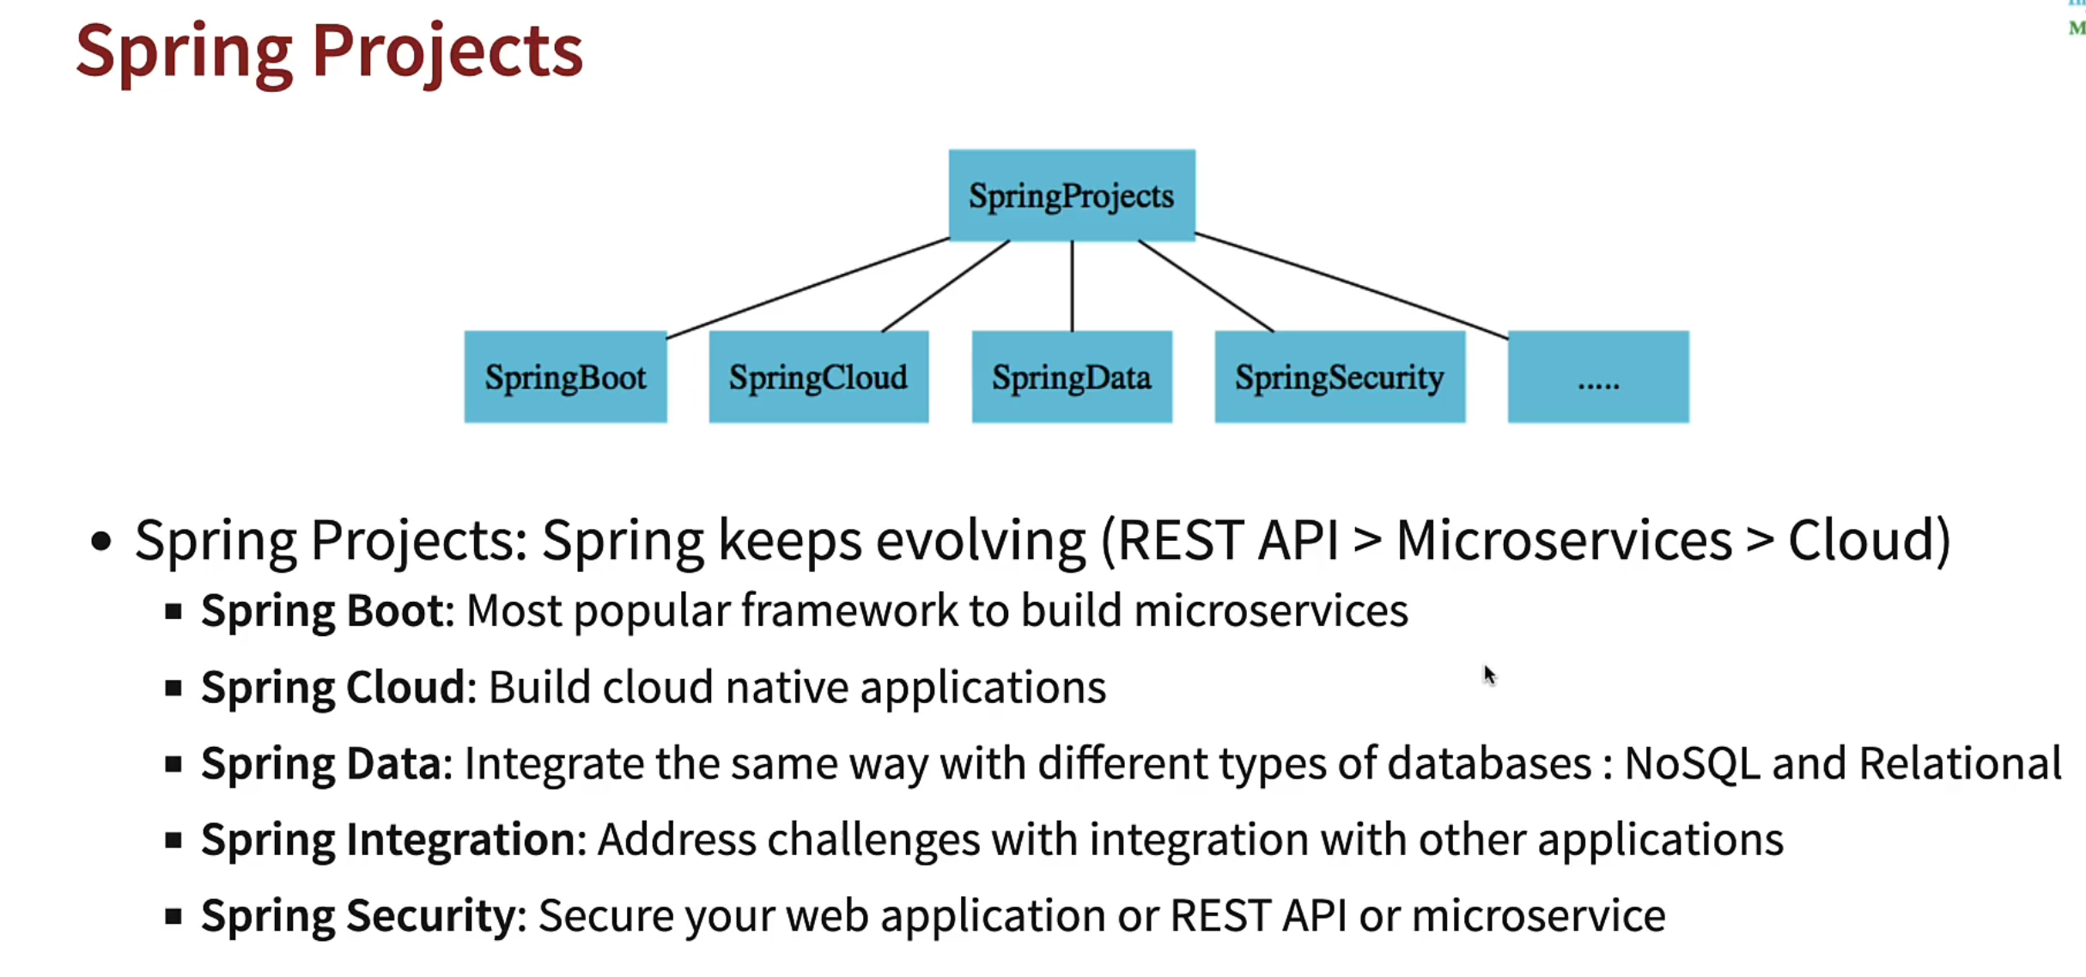

## Non functional requirements

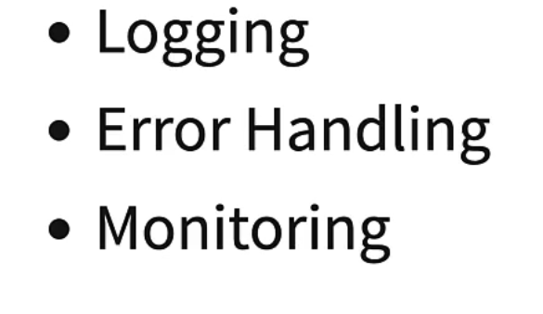

## Auto configuration

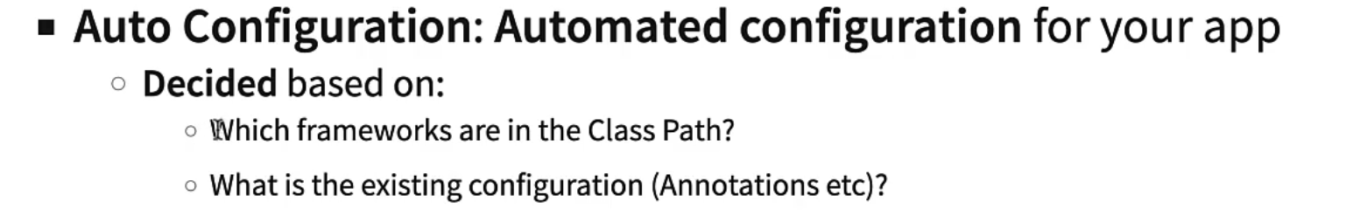

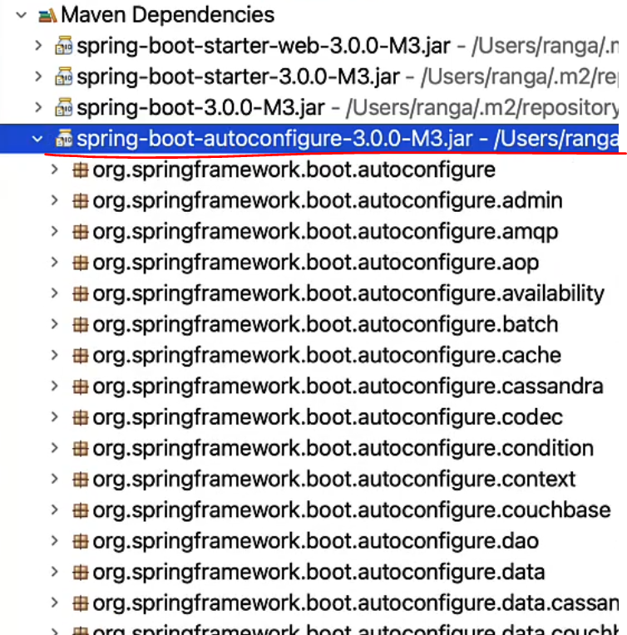

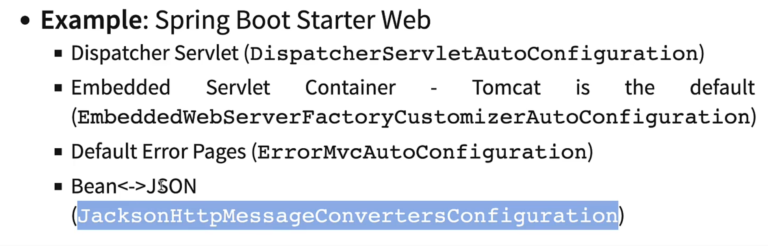

## Spring Boot DevTools

<https://www.youtube.com/watch?v=BvIM9gNTDM4>

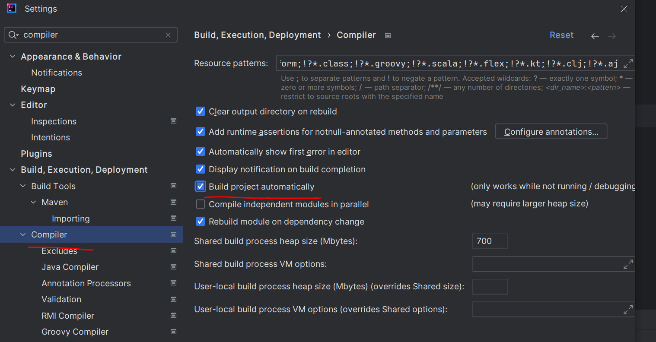

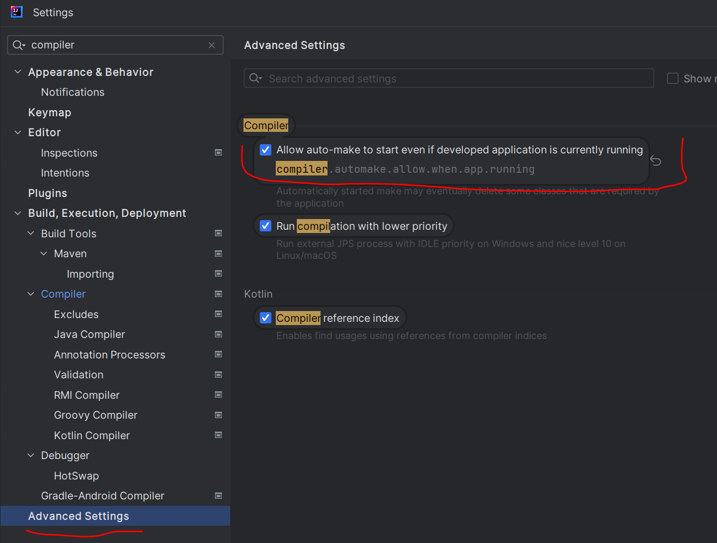

## Profiles

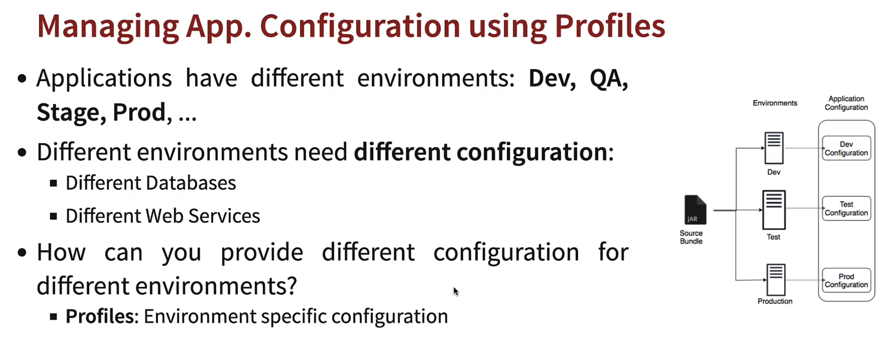

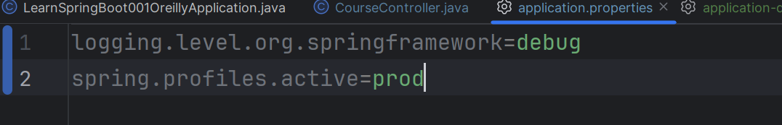

Properties in application.properties and application-prod.properties will be merged. In case of identical properties, the ones in application-prod.properties will have precedence.

## Logging levels

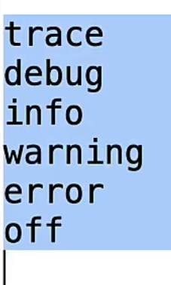

## Configuration properties

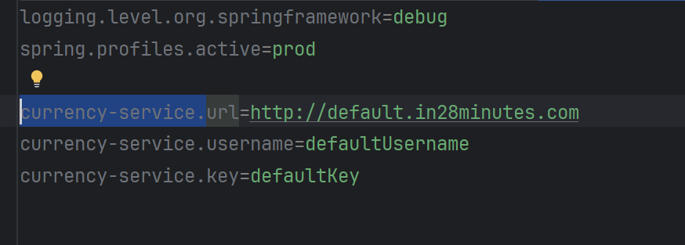

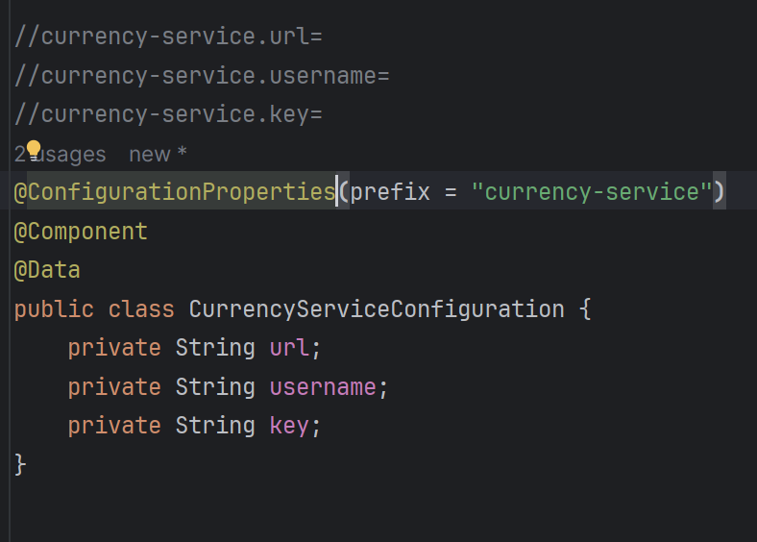

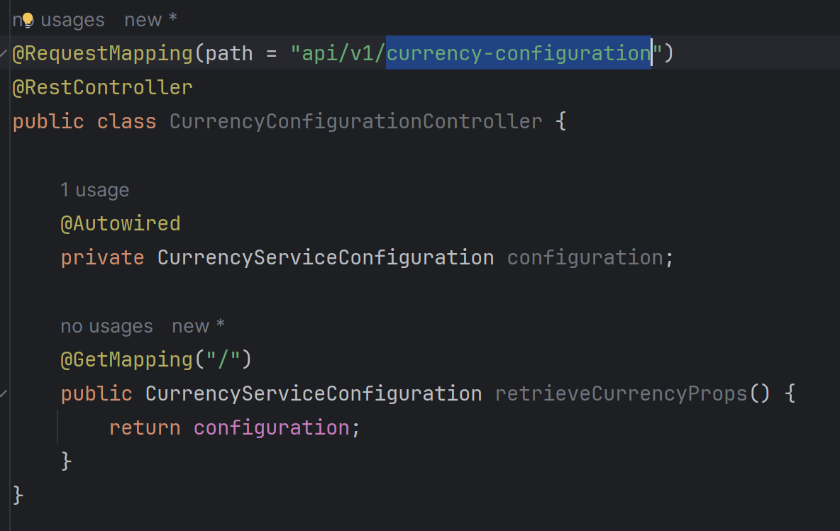

## Actuator

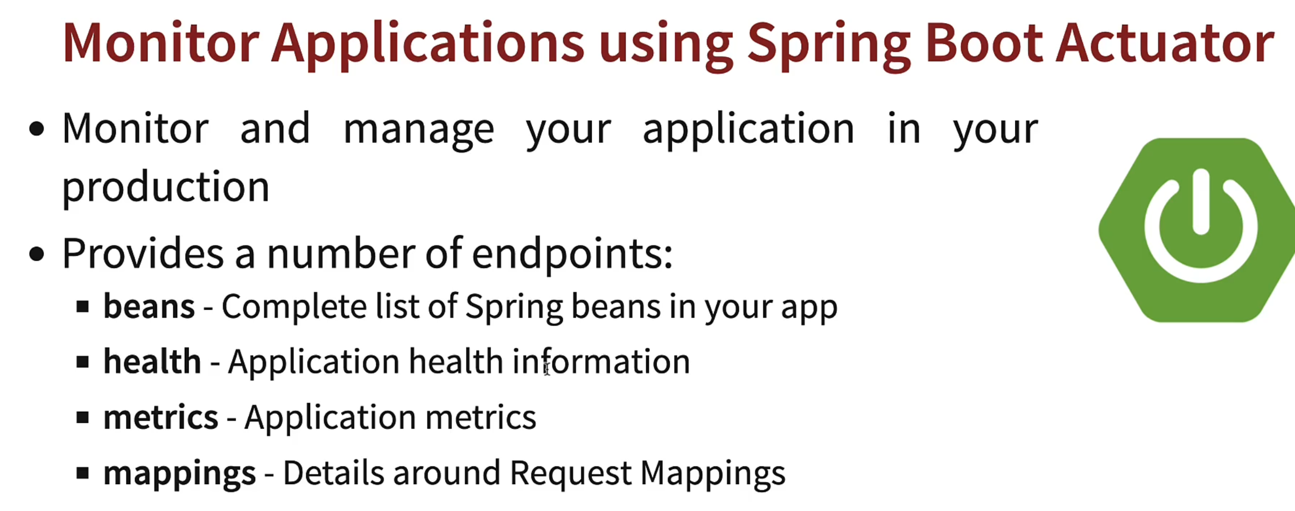

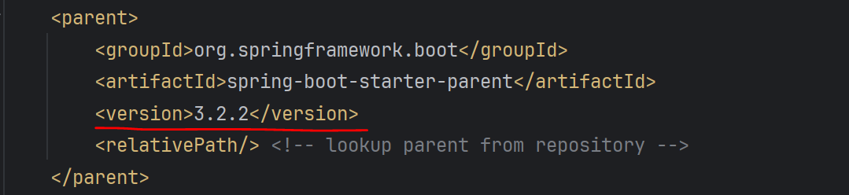

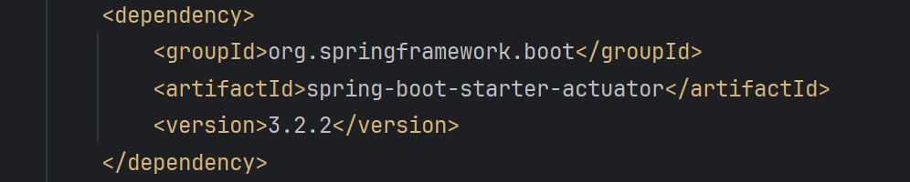

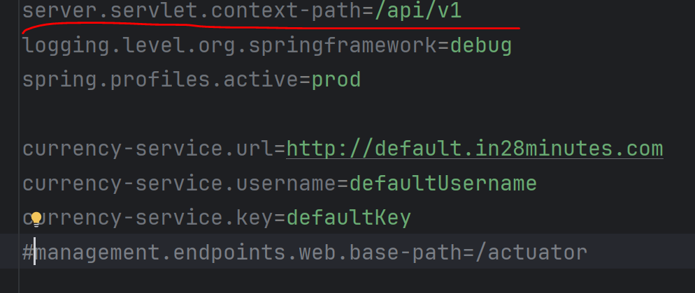

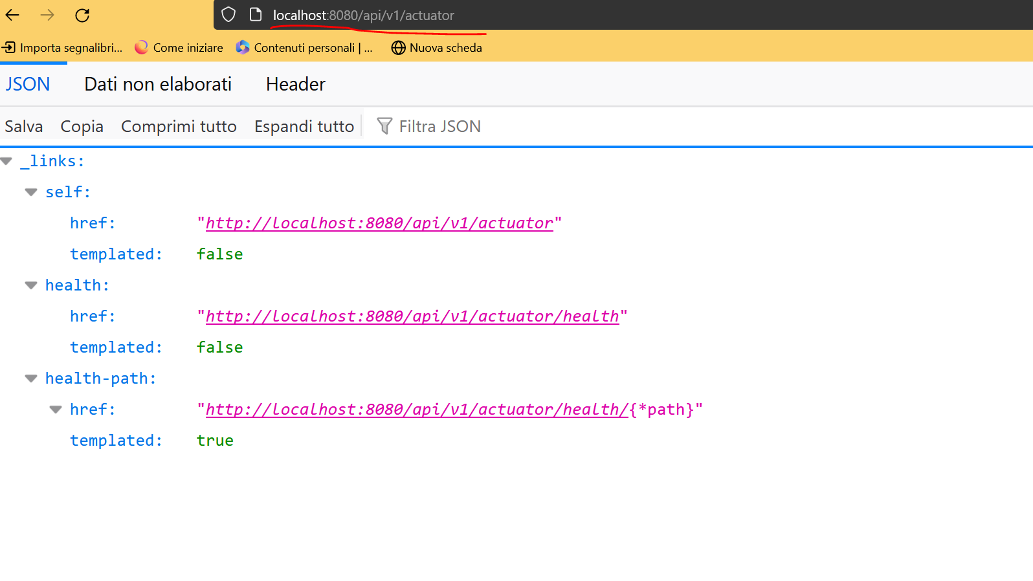

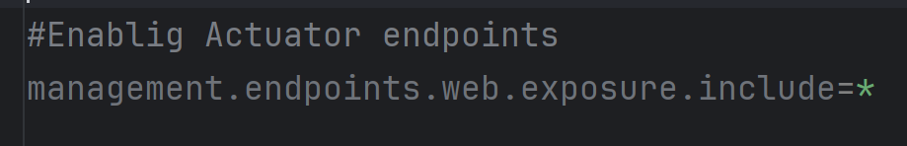

## SOAP web services with Spring and Spring Boot

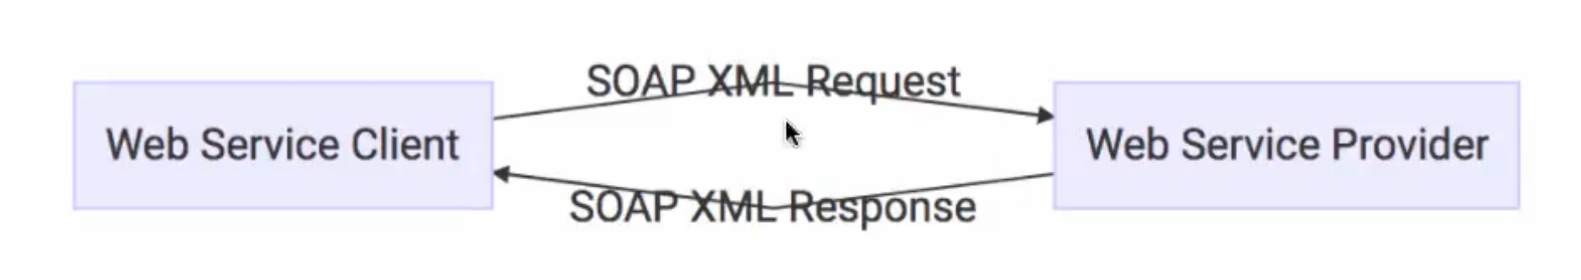

### Request

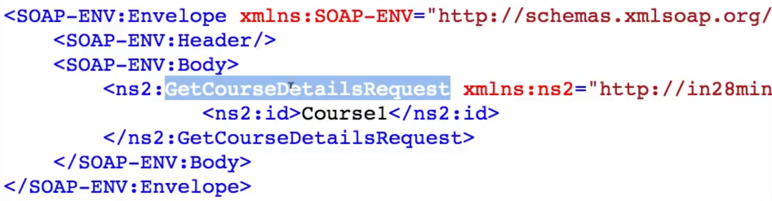

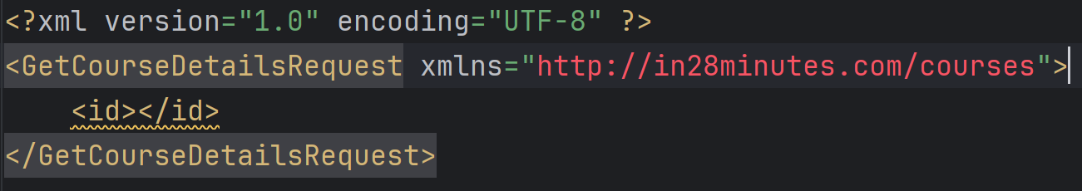

### Response

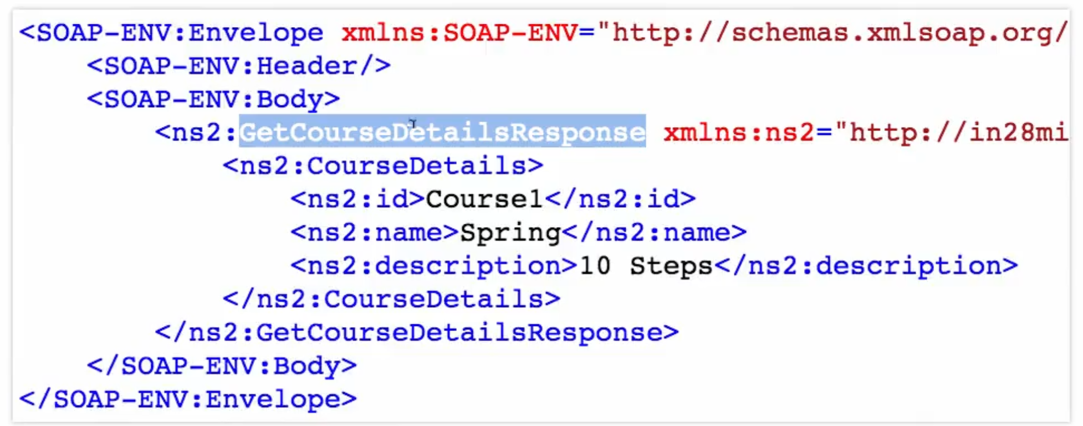

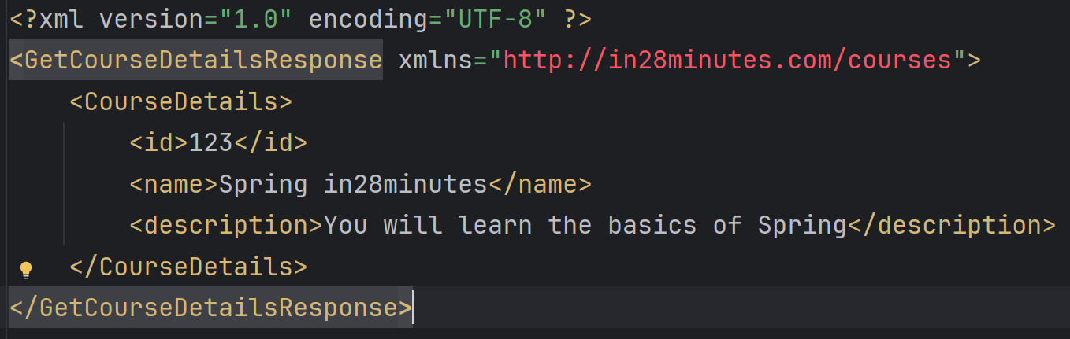

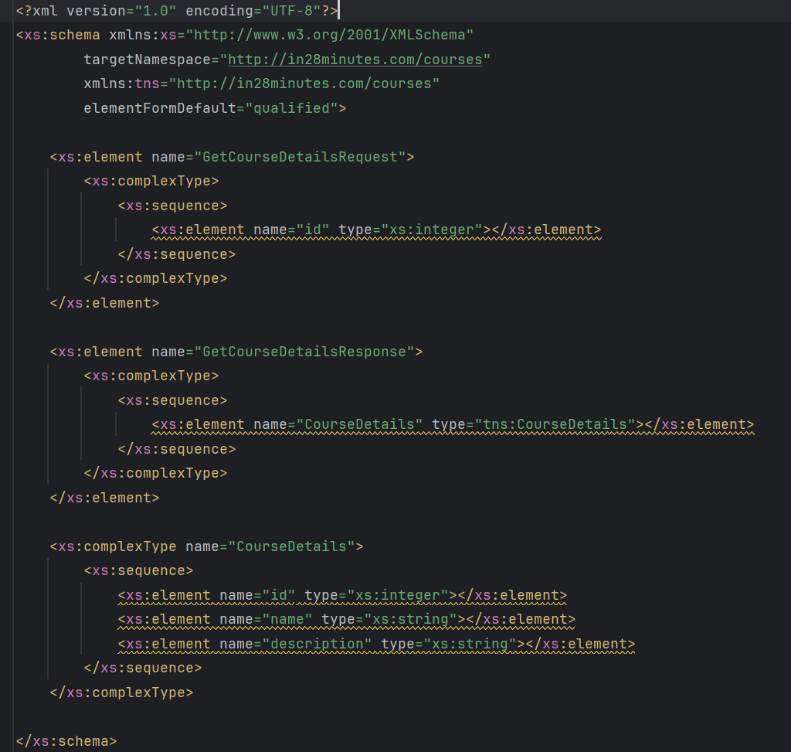

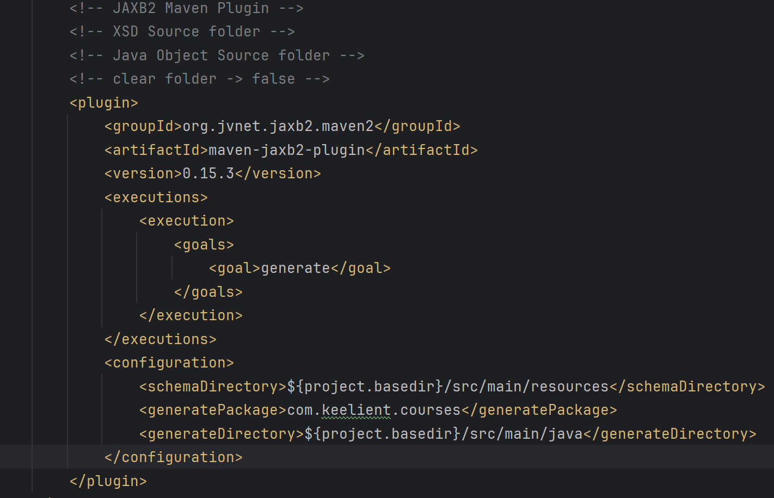

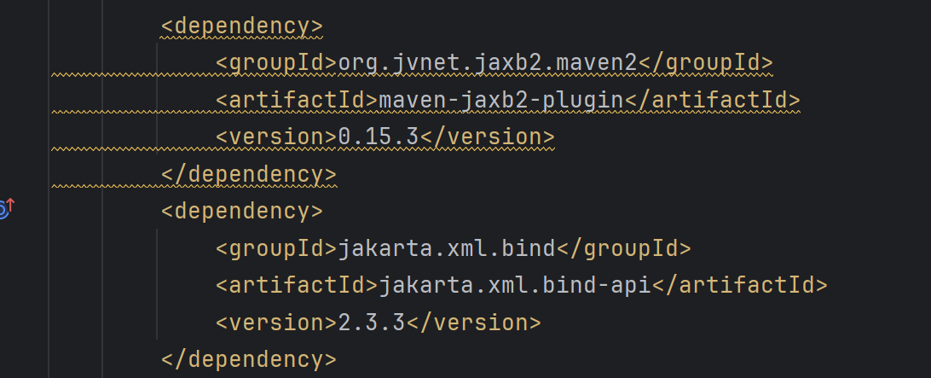

**mvn generate-sources**

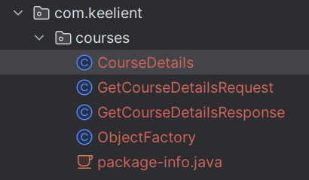

### WebServiceConfig

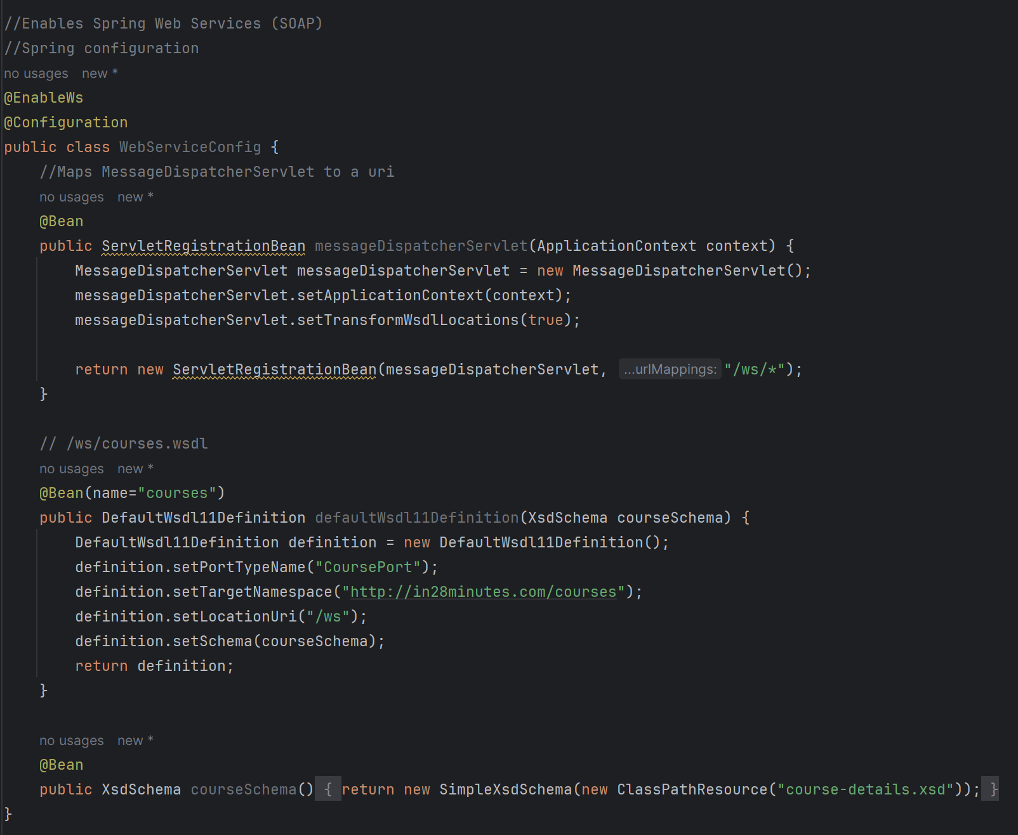

### WSDL

<http://localhost:8080/ws/courses.wsdl>

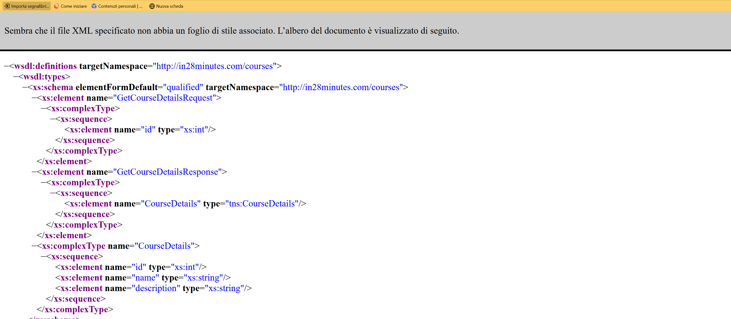

### Endpoint

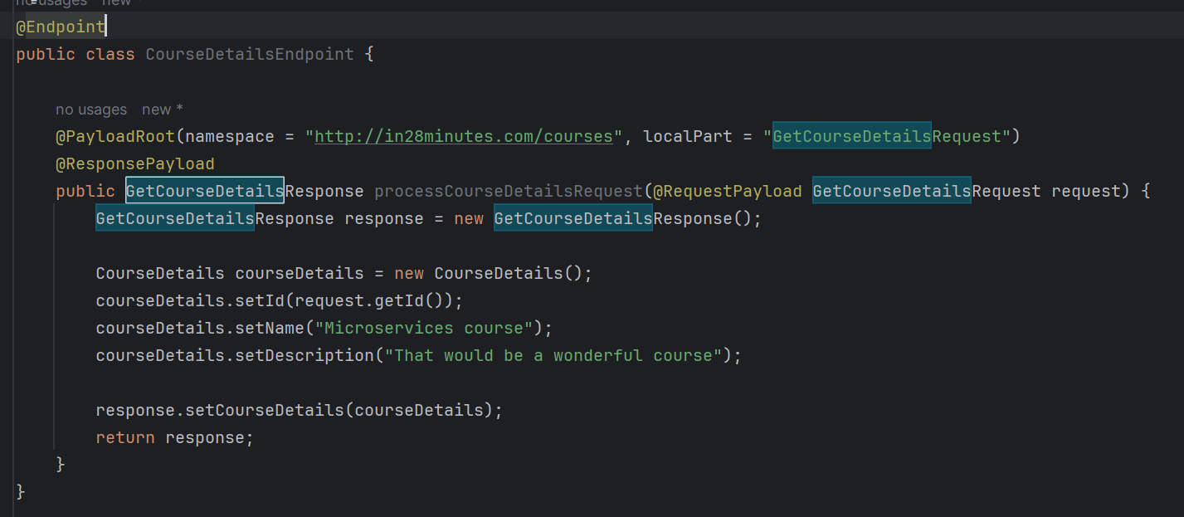

### Endpoint request (WIZDLER)

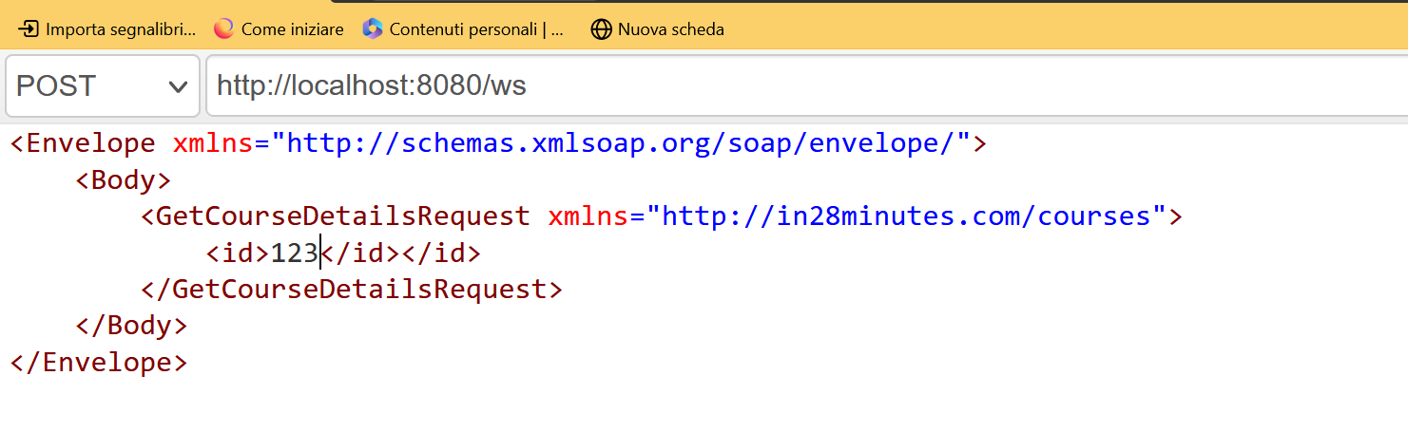

### Endpoint response (WIZDLER)

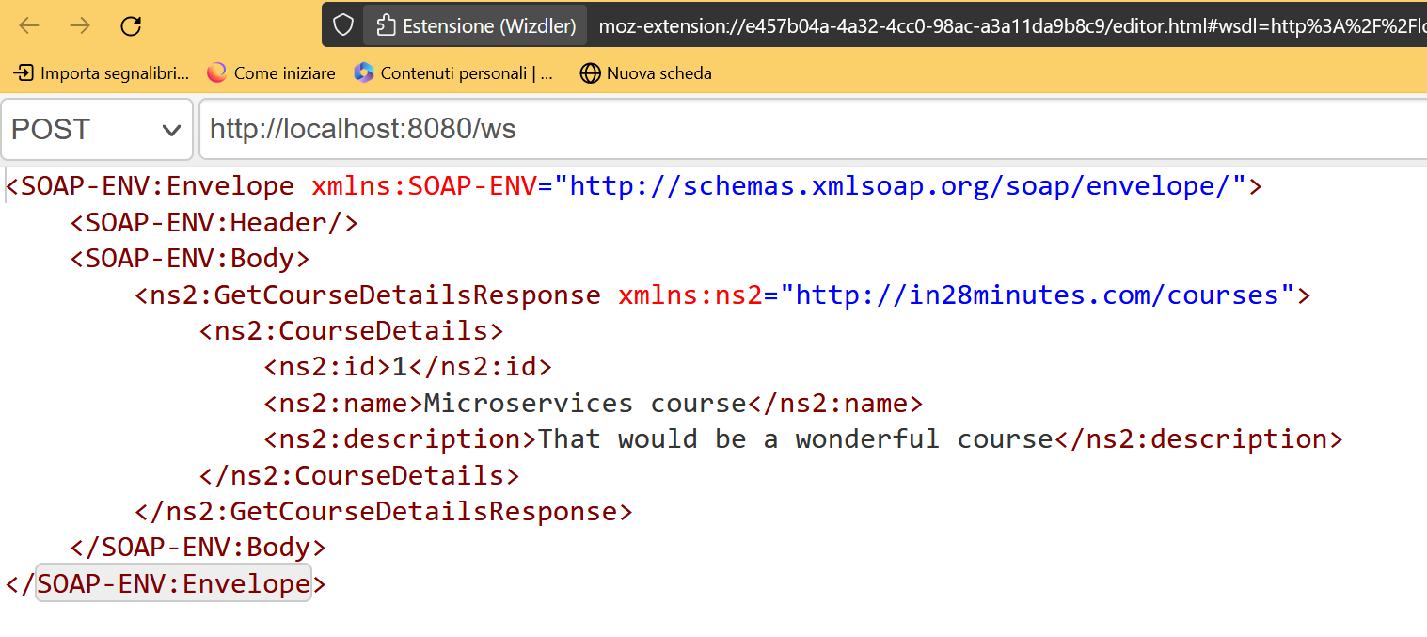

### Different Parts of a WSDL

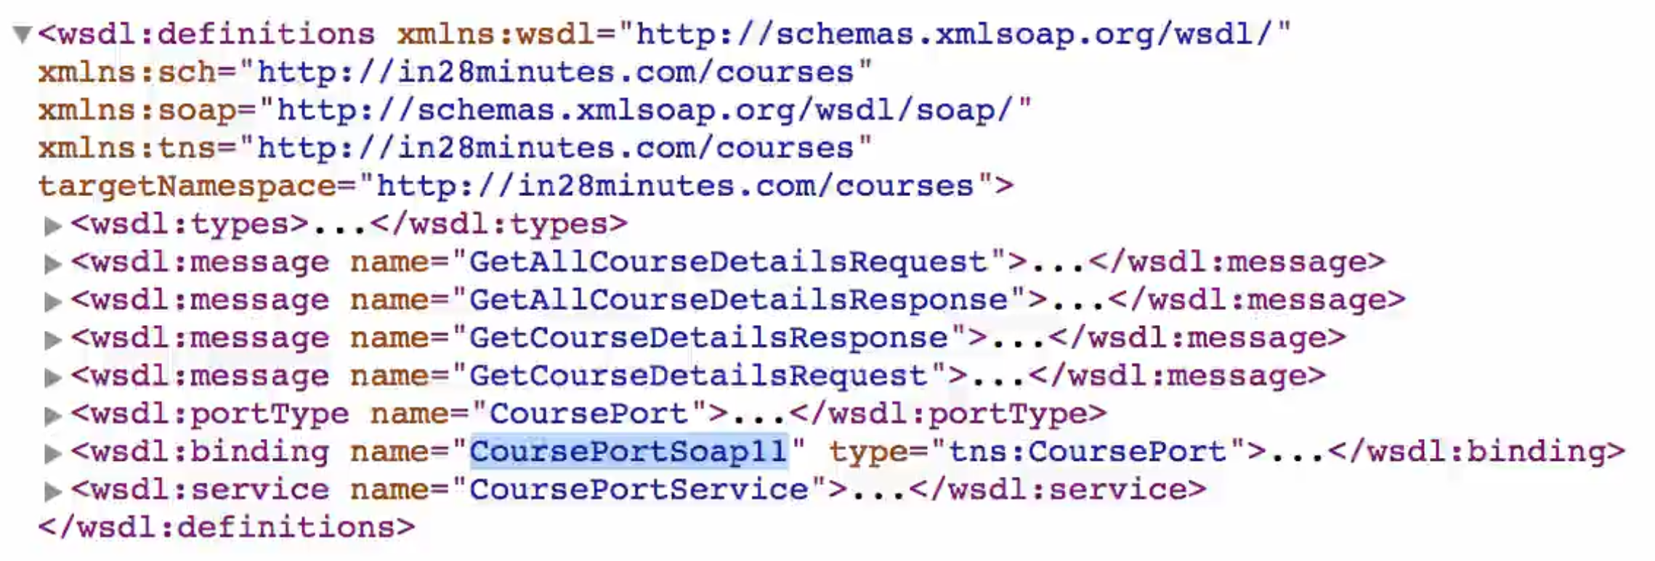

#### wsdl:types

Defines the content of the schema

#### wsdl:message

Defines the request and the response

#### wsdl:portType

Defines the operations (wsdl:operation). An operation is **a specific action a service can perform**.

#### wsdl:binding

Defines the how to call the services, the style (if it is document, means that XML is used for req and res) the transport (http or other).

#### wsdl:service

Definse the location (address) of the service.

## Exception handling

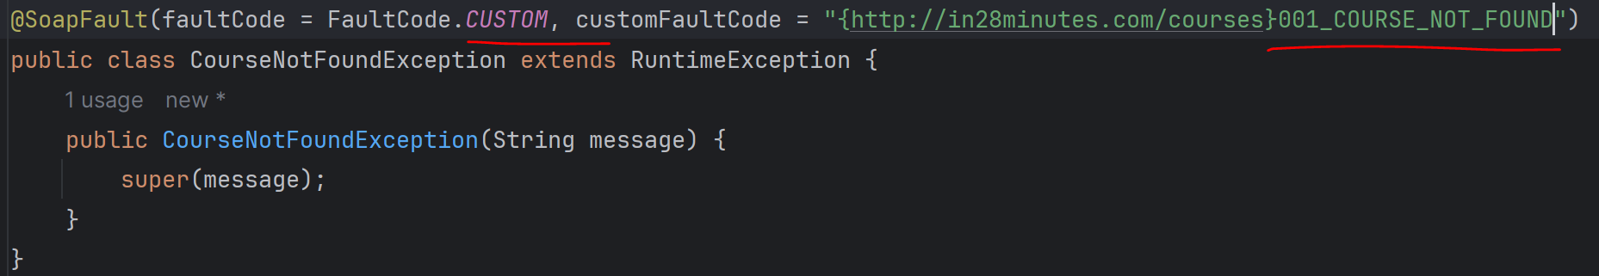

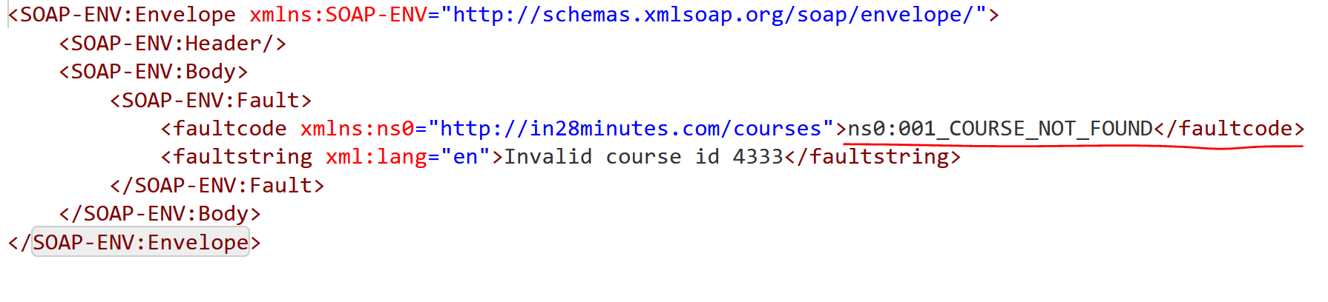

## XWSS (XML and web security)